Software Applications for Business – CA1

SAGE 50 – User Guide

Tetsuya Matsushita – x15045111

Contents

Quick Start Guide 2

Welcome 2

Network Sharing 3

Enter Company Details 3

Select your business type 4

Select Financial Year 4

VAT Details 5

Choose your currency 5

Confirm the details 6

Recording a payment 7

For bank Payments 7

# Quick Start Guide

To setup SAGE you need the following information ready.

* The name of the Chart of Accounts (COA) that best suits your company. For example, you can choose from Sole Trader, Partnership, Limited Company, Charities, or Basic.
* Company name and address
* Currency the company uses
* The financial year start date of the company
* VAT details

## Welcome

At the welcome screen, select Set up a new company.

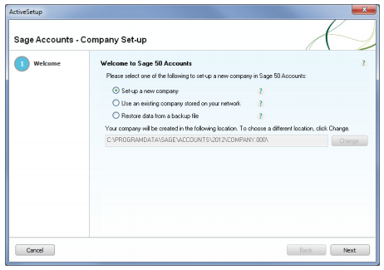

## Network Sharing

If multiple users are going to be using the program, configure a save location that is accessible on the network.

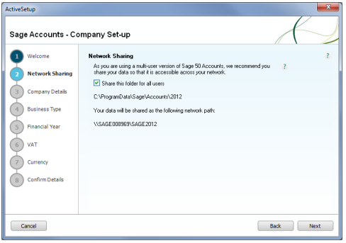

## Enter Company Details

Fill in the company details

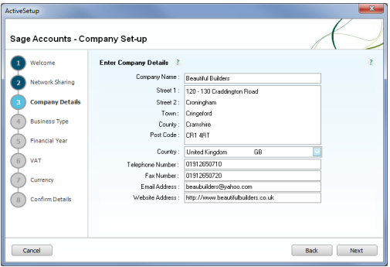

## Select your business type

Choose the business type that fits your company best.

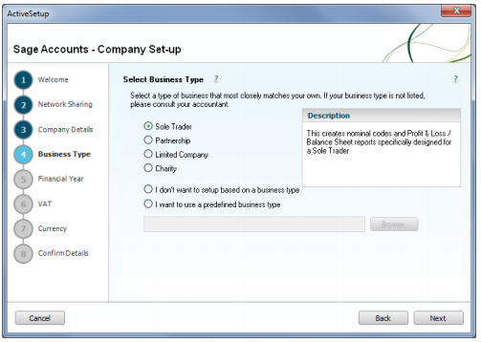

## Select Financial Year

Specify the details of the financial year for your company

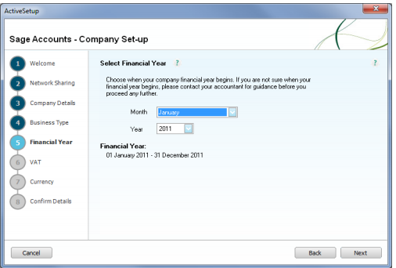

## VAT Details

Enter the VAT details for your company

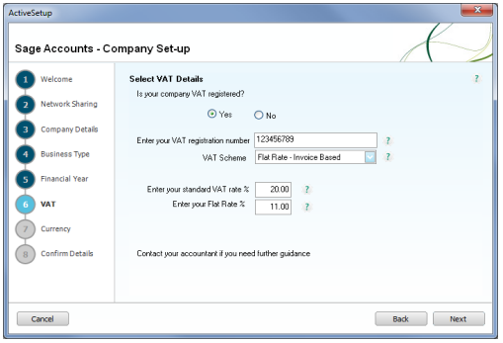

## Choose your currency

Select the currency for your company.

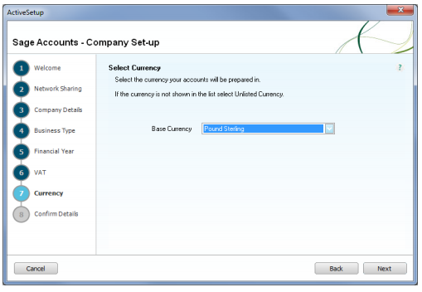

## Confirm the details

Confirm the details you have entered are correct. You are now setup.

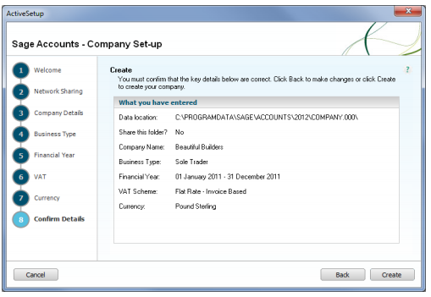

# Recording a payment

The instructions on how to record a bank payment will be laid out below.

## For bank Payments

1. Select Bank > New payment

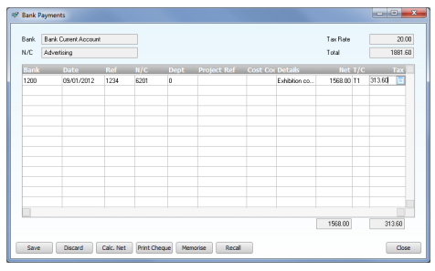

1. For each payment, enter the following details one line at a time; Bank, Date, Ref, N/C, Dept, Project Ref, Cost Code, Details, Net, T/C & Tax.
2. To accept entries, click ‘Save’. The details will be posted straight away and update the appropriate nominal account – the payment window will then clear.
3. You can now exit the payments window.